TÜRKİYE PUBLIC AND MUNICIPAL RENEWABLE ENERGY PROJECT(PUMREP)

360 kWe / 435.6 kWp Solar Power Plant of
Kayapınar Municipality

STAKEHOLDER ENGAGEMENT PLAN

MAY 2025

REVISION HISTORY

Version No | Version | Date of Issue | Prepared by | Submitted to
01 | Initial Draft | 26.03.2025 | ÇA Engineering | İLBANK
02 | Draft | 29.05.2025 | ÇA Engineering | İLBANK

TABLE OF CONTENTS
TABLE OF CONTENTS i
LIST OF TABLES iii
LIST OF FIGURES iv
LIST OF ABBREVIATIONS v
EXECUTIVE SUMMARY 6
1. INTRODUCTION/PROJECT DESCRIPTION 8
1.1. Objectives of the subproject 8
1.2. Components of the subproject 8
1.3. Subproject Location 8
1.4. Area of Influence 9
2. OBJECTIVE/ DESCRIPTION OF SEP 11
3. STAKEHOLDER IDENTIFICATION AND ANALYSIS 12
3.1. Methodology 12
3.2. Project Affected Parties 12
3.3. Other Interested Parties 12
3.4. Disadvantaged/ vulnerable individuals or groups 13
4. STAKEHOLDER ENGAGEMENT PROGRAM 16
4.1. Summary of stakeholder engagement done during subproject preparation 16
4.2. Summary of sub-project stakeholder needs and methods, tools, and techniques for stakeholder engagement 17
4.3. Stakeholder engagement plan 18
4.4. Reporting back to stakeholders 21
5. RESOURCES AND RESPONSIBILITIES FOR IMPLEMENTING STAKEHOLDER ENGAGEMENT ACTIVITIES 23
5.1. Project Implementation Unit (PIU) 23
5.2. Resources 23
5.3. Management functions and responsibilities 23
6. GRIEVANCE MECHANISM 25
6.1. Grievance Mechanism at National Level 25
6.2. Sub-Project Level Grievance Mechanism 26
6.3. Grievance Mechanism for Workers 27
6.4. Sensitive and Confidential Grievances 28
6.5. Grievance Mechanism Flow Chart 28
7. MONITORING AND REPORTING 30
7.1. Summary of how SEP implementation will be monitored and reported 30
ANNEXES 31
Annex-A 31
Annex-B 33
Annex- C 34
Annex-D 35
Annex-E 37

LIST OF TABLES
Table 1. Location of Sub-project and ETL 8
Table 2. Yenice Neighborhood vulnerable and disadvantage groups 13
Table 3. Influence/Interest Table for Stakeholder Prioritizatio 14
Table 4. Stakeholder Engagement Plan 19
Table 5. Roles and Responsibilities 23
Table 6. Grievance Mechanism Flow Chart 28

LIST OF FIGURES
Figure 1. Location of Sub-proje 9
Figure 2. Sub-project Area of Influence 10
Figure 3. Gercüş District Governorship Website 26

LIST OF ABBREVIATIONS

AoI | Area of influence
CIMER | Presidency’s Communication Centre
DC | Distributing center
EIA | Environmental Impact Assessment
ESF | Environmental and Social Framework
ESMP | Environmental and Social Management Plan
ESMR | Environmental and Social Management Report
ESMS | Environmental and Social Management System
ESS | Environmental and Social Standard
ETL | Energy Transmission Line
E&S | Environmental and Social
FI | Financial Intermediary
GBV | Gender Based Violence
GM | Grievance Mechanism
GMCP | Grievance Mechanism Contact Personnel
IFC | International Finance Corporation
IFI | International Financial Institutions
ILBANK | Iller Bank Inc.
MoEUCC | Ministry of Environment, Urbanization and Climate Change
MoM | Minutes of Public Participation Meeting
NGO | Non-Governmental Organizations
OHS | Occupational Health and Safety
PAP | Project Affected People
PMU | Project Management Unit
PIU | Project Implementation Unit
PUMREP | The Turkish Public and Municipal Renewable Energy Project
Project | PUMREP
RE | Renewable Energy
SEA/SH | Sexual Exploitation and Abuse/Sexual Harassment
SEP | Stakeholder Engagement Plan
Subproject | 360 kWe / 435.6 kWp Solar Power Plant of Kayapınar Municipality
SPP | Solar Power Plant
TurkStat | Turkish Statistical Institute
HV | High Voltage
WB  YIMER | World Bank  Foreigners Communication Centre

EXECUTIVE SUMMARY
The Türkiye Public and Municipal Renewable Energy Project (PUMREP) aims to support the Government of Türkiye to scale-up renewable energy use in the public sector by focusing on central government buildings and municipalities. The Project will contribute to expanding the distributed Renewable Energy (RE) market in public facilities by addressing the barriers discussed above and help demonstrate leadership in the public sector to use sustainable energy solutions to deliver on the country’s climate mitigation commitment and enhance energy security.
The PUMREP will support introducing RE technologies in municipalities and will be implemented by İller Bankası A.Ş. (ILBANK). The RE installations will be primarily used to offset the overall energy consumption from public facilities (e.g., administrative buildings, water supply and water treatment, public lighting, etc.) and thus reduce the municipalities’ energy bills.
ILBANK has established an Environmental and Social Management System (ESMS) effective on 24th of Dec 2023. The ESMS is aimed at ensuring systematic identification, assessment, management, monitoring, and reporting of the environmental and social (E&S) risks and impacts of the projects and subprojects financed by the IFIs. This process should be implemented on an ongoing basis throughout their loan duration in line with the requirements of the national legislation, international agreements and conventions ratified by Türkiye and E&S standards of lending IFIs (World Bank for the PUMREP). As a critical element of the ESMS, ILBANK has adopted and published an E&S Policy applicable to all ILBANK projects and subprojects financed through IFIs.
The sub-project is planned to be built in Batman Province Gercüş District, Kayapınar Town, Yenice Neighborhood lot 21 of block 106. The parcel in question is 20,000 m². 4,650 m² of the land will be used for the solar energy plant. Land ownership belongs to National Real Estate Directorate and has been allocated to Kayapınar Municipality.
The sub-project is categorized as Moderate Risk Category as per ILBANK ESMS and World Bank’s Environmental and Social Framework (WB ESF), 2018. One of the tasks under the scope of the subproject is the preparation of a Stakeholder Engagement Plan (SEP) in accordance with ILBANK ESMS, WB ESF, and the national legislation in force in Türkiye.
The principles of openness and life cycle, informed participation and feedback, inclusiveness and sensitivity, and flexibility were used to define the stakeholders of the subproject. In this way, stakeholder consultations will be conducted openly throughout the life cycle of the project, all stakeholders will be informed and their feedback will be received with appropriate tools and methods, and special attention will be paid to the participation of vulnerable individuals or groups so that all stakeholders have equal access to information.
The main objectives of this SEP are presented below;
• Identify stakeholders affected by the sub-project and establish and maintain constructive relationships with all identified stakeholders;
• Establish and promote effective and inclusive relationships with "project-affected parties", "other interested parties" and "vulnerable/disadvantaged groups" throughout the sub-project life cycle;
• Ensuring that sub-project information is publicised in a timely, understandable and accessible manner,
• Providing means for "project-affected parties", "other interested parties" and "vulnerable/disadvantaged groups"by the sub-project to express their opinions, suggestions and grievances
In order to obtain information about the current socio-economic structure of the neighborhood in the subject area studies, as well as to determine the level of information about the sub- project, opinions and concerns about the sub-project, a sub-project site visit was organized by CA Engineering officer on 09.02.2025. Finally, a Grievance Monitoring Table is presented at the end of this SEP and the tools of monitoring activities to be carried out to evaluate the performance and effectiveness of the sub-project are suggested.

INTRODUCTION/PROJECT DESCRIPTION

Objectives of the subproject
The Public and Municipal Renewable Energy Project (PUMREP) (hereinafter the “Project”) aims to support the Government of Türkiye to scale-up Renewable Energy (RE) use in the public sector by focusing on central government buildings and municipalities. The sub-project involves the establishment and operation of "Kayapınar Municipality 360 kWe / 435.6 kWp Solar Power Plant, located within the borders of Yenice Neighborhood in the Kayapınar Town, Gercüş District of Batman Province The Project is financed by World Bank (WB) to support introducing RE technologies in municipalities. İller Bankası A.Ş. (ILBANK) acts as the Financial Intermediary (FI). The RE installations will be primarily used to offset the overall energy consumption from public facilities (i.e. administrative buildings, water supply and water treatment, public lighting, etc.) and thus reduce the municipalities’ energy bills.
The potential environmental and social risks and impacts of the Project is provided in the Environmental and Social Management Plan (ESMP) which is available at [link ]. The subroject’s environmental and social risk classification is determined as moderate.
This document is prepared in accordance with Environmental and Social Standard (ESS) 10 on Stakeholder Engagement and Information Disclosure, as part of the Environmental and Social Framework (ESF) Kayapınar Municipality is responsible for stakeholder engagement activities and grievance resolution, ensuring that the sub-project is carried out in an inclusive and participatory manner.

Components of the subproject
The sub-project includes the installation of solar power plants (SPP) in the lot 21 of block 106. Within the scope of sub-project activities; 20 m underground and then 20 m overhead line will be made and the network connection will be made with a loose connection. ETL route is located on the same parcel of land as SPP. The connection point to be made to the system is also located on the same parcel of land. No permit is required.
The existing stabilized road will be used as the sub-project access road within the scope of the sub-project. No new road will be constructed.

Subproject Location
The sub-project covers the establishment and operation of "435.6 kWp / 360 kWe Solar Power Plant" by Kayapınar Municipality on lot 21 of block 106 located within the borders of Yenice Neighborhood, .Kayapınar Town, Gercüş District of Batman Province.
The project area is located on unused land, which does not host any agricultural, livestock, or commercial activities. Currently, no grazing or animal husbandry activities are being carried out within the sub-project site.
There are naturally grown oak and hornbeam trees present near the sub-project area. However, these trees are outside the fenced boundary of the subproject site; therefore, no cutting or relocation of trees will be required.
Approximately 50 meters west of the project site, there is a structure used for measuring the groundwater level. This structure will not be affected by the implementation of the subproject.
Table 1. Location of Sub-project and ETL
Province | Distirct | Neighborhood | Project Component | Block | Lot
Batman | Gercüş | Yenice | Solar Power Plant (SPP) | 21 | 106
Batman | Gercüş | Yenice | ETL | 21 | 106

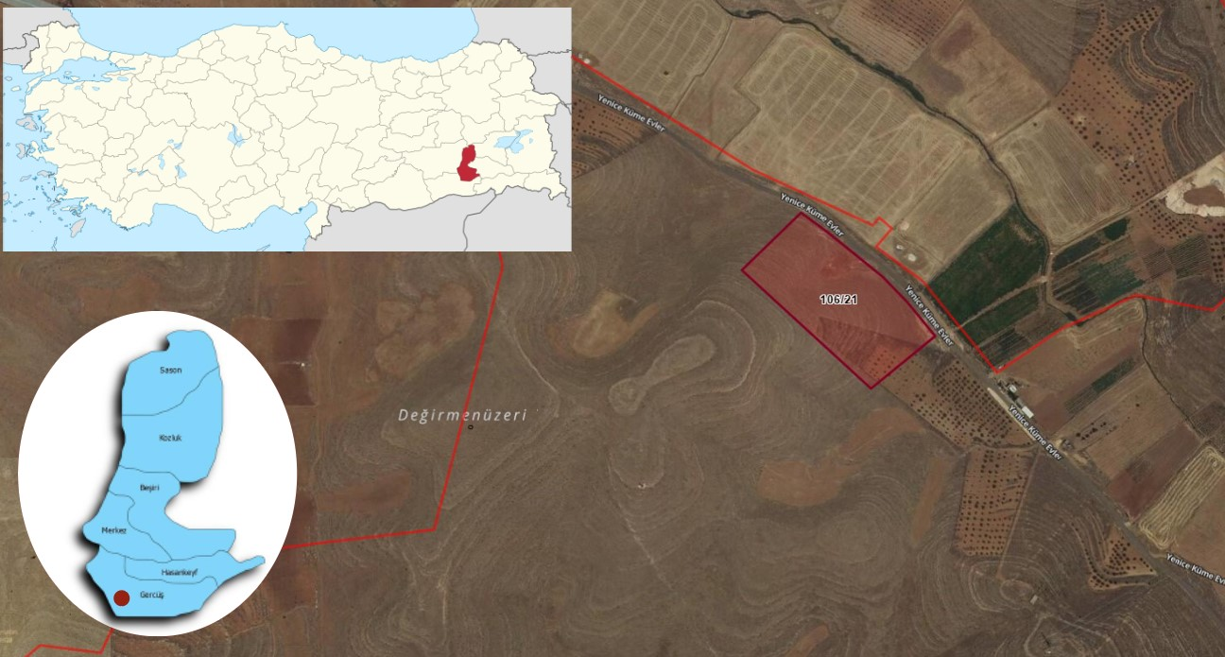
Figure 1. Location of Sub-proje

Area of Influence
The Area of Influence (AoI) for the sub-project is determined based on the anticipated environmental and social impacts during the construction, operation, and maintenance phases of the project, such as local ecosystems, nearby communities, and critical infrastructure. The transportation route passes in front of the neighborhood and does not intersect with sensitive structures such as health and school. Therefore, no traffic impact is expected during transportation and equipment transportation to the site.
Within the scope of sub-project activities; the impact area was determined as a result of interviews with local people and mukhtars during the site visit, based on components such as dust emissions, environmental noise, provision of local employment, local people's opinions about the sub-project, etc. Additionally, details regarding dust emissions and environmental noise calculations to occur during sub-project activities are provided in ESMP Report.
It is anticipated that the impacts determined within the scope of the subproject activities will be attenuated within 50 meters. Therefore, the area of ​​influence was determined as 50 meters. The Yenice neighborhood, where the sub-project site is located, the transportation route and the ETL route were included in the area of ​​influence. These impacts will be seen at a certain time during the construction process and will end when the construction activities are completed.
The closest sensitive receptor to the subproject site is the residences located 200 meters away. During the field visits, 3 people living around the subproject area and the Muhtarof Yenice neighborhood were interviewed, and the environmental and social risks of the subproject were explained and their opinions, suggestions and concerns regarding the subproject activities were asked. In addition to not detecting any negative opinions, the transportation channels to be used in case of any complaints were provided. The ETL will pass through the parcel allocated for the sub-project and be connected to the existing pole. There are no sensitive structures such as schools or health facilities on the transportation route and ETL route.
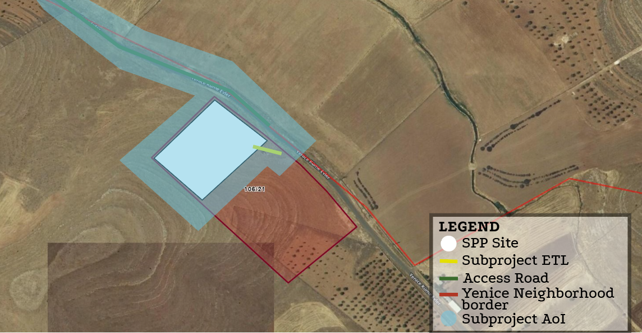
Figure 2. Sub-project Area of Influence

OBJECTIVE/ DESCRIPTION OF SEP
The overall objective of this SEP is to define a program for stakeholder engagement, including public information disclosure and consultation throughout the entire sub-project cycle. The SEP outlines how the Kayapınar Municipality PIU (Project Implementation Unit) will communicate with stakeholders and includes a mechanism by which people can raise concerns, provide feedback, or make complaints about subproject activities or related issues. The SEP specifically emphasizes methods to engage vulnerable groups at risk of being excluded from the project benefits.
As an important tool in the management of the environmental and social impacts of the sub-project, SEP increases awareness of the sub-project, identifies stakeholders’ views, ensures that their opinions and concerns are taken into consideration, and increases trust in the sub-project processes. The Stakeholder Engagement Plan (SEP) aims to support Kayapınar Municipality in identifying its stakeholders and fostering constructive relationships, particularly with those affected by the sub-project.
The SEP promotes effective and inclusive engagement with affected parties throughout the subproject lifecycle, addressing potentially impactful issues. It ensures that information on environmental and social risks and impacts are disclosed in a timely, understandable, and accessible manner. Additionally, the SEP provides affected parties with inclusive tools to voice concerns and grievances, enabling Kayapınar Municipality to respond and manage these effectively. By creating a transparent and respectful environment, the SEP encourages the inclusion of diverse cultural norms and engagement capacities, fostering fair and open dialogue to address stakeholder concerns engagement“.
SEP has been developed to comply with both national legal requirements and World Bank’s Environmental and Social Standard 10 (ESS10). This project-specific SEP is a public document that will be regularly updated based on ongoing discussions and engagement with stakeholders, reflecting their views and input throughout the sub-project.

STAKEHOLDER IDENTIFICATION AND ANALYSIS
In the stakeholder identification process, the potential impacts of the sub-project are assessed, and strategies for engaging stakeholders are developed, including the frequency and methods of communication. It is especially important to focus on identifying vulnerable or disadvantaged groups who may be more severely affected by the sub-project or face challenges in participating in the engagement process. Identifying stakeholders is an ongoing activity and will be continuously reviewed and updated as needed.

Methodology
To follow best practices in stakeholder engagement, the project will apply the following principles:
- Openness and Life-cycle Approach: Public consultations will be held throughout the entire project life cycle in an open and transparent way, ensuring that there is no outside influence, manipulation, or intimidation.
- Informed Participation and Feedback: Relevant information will be shared with all stakeholders in an accessible format. There will be opportunities for stakeholders to provide feedback, and their comments and concerns will be carefully analyzed and addressed.
- Inclusiveness and Sensitivity: The stakeholder identification process will focus on building strong, effective relationships and ensuring that all stakeholders are included in the consultation process. Everyone will have equal access to information. Engagement methods will be chosen based on the needs of the stakeholders, with particular attention to vulnerable groups such as women, the elderly, people with disabilities, displaced persons, migrant workers, and communities. Cultural sensitivities will also be carefully considered to ensure the participation of diverse ethnic groups.
- Flexibility: If social distancing, cultural context (for example, particular gender dynamics), or governance factors (for example, high risk of retaliation) inhibits traditional forms of face-to-face engagement, the methodology should adapt to other forms of engagement, including various forms of internet- or phone-based communication.
For Kayapınar Municipality SPP project, the following stakeholders have been identified and analyzed per subproject component. These stakeholders include affected parties, other interested parties and disadvantaged/vulnerable individuals or groups.

Project Affected Parties
The term "project-affected parties" refers to individuals or groups who are likely to be affected by the sub-project due to direct impacts or potential risks on their physical environment, health, safety, cultural practices.
The key PAP’s who will be cooperated and consulted about and during the sub-project, including individuals, groups and communities are:
- Residents of Yenice Neighborhood (304 people)
- Workers to be employed for the construction activities
- Local businesses in the process of supplying materials and equipment

Other Interested Parties
Other Interested Parties are individuals or groups that are not directly involved in the project, but may nevertheless have an interest in project outputs, decisions or activities. A list of this stakeholder group is presented below:
• Residents living outside Yenice neighbourhood in Gercüş District, which are close to the sub-project area
• Ministry of Industry and Technology
• Ministry of Energy and Natural Resources
• Ministry of Environment, Urbanization and Climate Change
• Ministry of Labor and Social Security
• Batman Social Security Institution Provincial Directorate
• Batman Provincial Directorate of Industry and Technology
• Batman Provincial Directorate of Environment, Urbanisation and Climate Change
• Batman Gercüş Governorship
• Batman Gercüş Municipality
• Batman Provincial Civil Society Relations Directorate
• Anadolu Agency Regional Directorate
• Local Television Channels and Newspapers

Disadvantaged/ vulnerable individuals or groups
Disadvantaged/Vulnerable individuals or groups are persons who may be disproportionately impacted or further disadvantaged by the project(s) compared with any other groups due to their vulnerable status, and that may require special engagement efforts to ensure their equal representation in the consultation and decision-making process associated with the project.
However, vulnerable and disadvantaged groups residing in Yenice Neighborhood, where the sub-project activities will be carried out, may be adversely affected due to their limited ability to express concerns, understand the interests of the sub-project, or access and comprehend project-related information.
Details of Vulnerable and Disadvantage Groups according to the information obtained from the mukhtar of Yenice Neighborhood, the closest settlement to the sub-project site, are given in Table 2.
Table 2.Yenice Neighborhood vulnerable and disadvantage groups
Vulnerable and Disadvantage Groups | Number of People
Non-literate | 23
Chronic diseases | 47
Surviving on social assistance from the state, associations or individuals | 17
Over 70 years of age and living alone | 31
Female-headed households | 5
Total Vulnerable and Disadvantage Groups | 123
Source: Mukhtar Meetings, 2025.
According to the interviews conducted with mukhtar of Yenice neighborhood on 09.02.2025 during the consultations carried out within the scope of SEP and the information received from the municipality staff, there are no refugee residing in the sub-project area. Lack of access to the transportation budget due to unemployment or poverty will cause difficulties in reaching vulnerable/disadvantaged individuals/groups in terms of engagement in consultation activities and events. Within the sub-project impact area, there is no structure. Additionally, the nearest occupied houses are located approximately 200 meter from the sub-project site. However, programs will be developed to facilitate the engagement of the disadvantaged/disadvantaged groups/individuals in consultations. In the event of any employment opportunity for the unemployed within the scope of the sub-project, an announcement will be made to the muhtars' offices and local people will be prioritized in recruitment. There is no language spoken in the region other than Turkish. According to the information received, there are approximately 149 female in Yenice neighborhood. Therefore, the female population in Yenice neighborhood, which is affected by the sub-project, constitutes 49% of the total population.
Programs will be developed so that the vulnerable and disadvantage groups, whose details are provided in Table 2 do not have difficulties in participating in the consultation activities and events. A shuttle service will be provided to ensure that the said group participates in the consultation meetings. They will be picked up from their homes and returned to their homes upon completion of the event.
How each stakeholder group will be affected by the project and their interest in the project; the area of influence and the nature and quantity of the impacts that may arise were determined. The stakeholders determined as a result of the interviews with the mukhtar of Yenice neighborhood and local people, interviews with non-governmental organizations, public institutions and organizations and the information obtained from Kayapınar Municipality are given in Table 3.
Table 3. Influence/Interest Table for Stakeholder Prioritizatio
Stakeholder Group |  |  | Level of Interest | Level of Influence
Stakeholder | Project Affected Parties | - Communities likely to be affected by the construction works in the scope of component (Yenice Neighborhood)  - Workers to be employed for the construction activities | High | High
Stakeholder | Other Interested Parties | Public Institutions  - Residents living outside Yenice neighbourhood in Gercüş District, which are close to the sub-project area  - Ministry of Industry and Technology  - Ministry of Energy and Natural Resources  - Ministry of Environment, Urbanization and Climate Change (MoEUCC)  - Ministry of Labor and Social Security  - General Directorate of Labor  - General Directorate of Occupational Health and Safety  - Batman Governorship  - Batman Social Security Institution Provincial Directorate  - Batman Provincial Directorate of Environment, Urbanization and Climate Change  - Batman Provincial Directorate of Environment, Urbanisation and Climate Change  - Batman Provincial Directorate of Civil Society Relations  - Batman Gercüş Governorship  - Batman Gercüş Municipality | High | Low
Stakeholder | Other Interested Parties | NGOs  - Batman Provincial Civil Society Relations Directorate | High | Low
Stakeholder | Other Interested Parties | Local Press  - Batman Newspaper  - Batman Çağdaş Newspaper  - Batman Sonsöz Newspaper  National Press  - Anadolu Agency  - Demirören News Agency | High | Low
Vulnerable and Disadvantaged or groups |  | 129 people living in Yenice Neighborhood  - Non-literate  - Chronic diseases  - Surviving on social assistance from the state, associations or individuals  - Over 70 years of age and living alone  - Female-headed households | Moderate | High

STAKEHOLDER ENGAGEMENT PROGRAM
The main objectives of the stakeholder engagement programme and the planned timetable for the various stakeholder engagement activities are to define at what stages and at what intervals these activities will be carried out throughout the life of the sub-project. Information is provided on how the public will be made aware of future opportunities to review information and provide their views, if decisions about public meetings, locations and timing of meetings have not yet been made.

4.1. Summary of stakeholder engagement done during subproject preparation
In order to inform the public about the sub-project, a field visit was carried out on 09.02.2025 to engage with the local community, gather their opinions and suggestions, and provide detailed information about the project. As part of this process, an interview was conducted the with Yenice neighborhood mukhtar and Kayapınar Municipality officials about the usage status of the sub-project site and the disadvantaged groups living in the region. Within the scope of the interviews;
- It was determined that the sub-project site was not currently used by the local people for any purpose, and that there were no refugees or child-headed people living in Yenice neighborhood, the closest settlement to the sub-project site.
- The mukhtar, local authorities and local residents were questioned about the existence of cultural heritage. No tangible or intangible cultural heritage assets were identified in the sub-project site and within the influence area.
During the consultations with the local community, potential environmental and social risks associated with the existing solar power plant were mentioned, and their views, suggestions and concerns about the sub-project were discussed. They conveyed their expectations for their contributions to the region at the local level and their demands for local employment. It was conveyed that local resources would be prioritized for personnel, materials and equipment needs within the scope of the sub-project. Information was provided about the Kayapınar Municipality complaint mechanism, which they could use to share any views or complaints during both the construction and operation phases of the sub-project.
In addition, within the scope of the Stakeholder Engagement Plan, consultation meetings were held with Yenice neighborhood residents (3 people) and the association president by CA Engineering authority on 09.02.2025. In order to obtain general information about the socio-economic situation of Yenice neighborhood and to learn about their knowledge levels about the sub-project, the mukhtar of a "Community Level Survey" form was filled out by the consultant company as a result of interviews with the mukhtar of Yenice neighborhood.
The Kayapınar Municipality Solar Power Plant (SPP) Project is one of the sub-projects implemented under the Türkiye Public and Municipal Renewable Energy Project (PUMREP), which aims to promote sustainable urban development through renewable energy investments.
The Environmental and Social Management Plan Checklist (ESMP-Checklist) and the Stakeholder Engagement Plan (SEP) for the sub-project were prepared in line with Turkish environmental and social legislation, the World Bank Environmental and Social Standards (ESSs), the World Bank General EHS Guidelines, the Industry Sector Guidelines, and ILBANK’s Environmental and Social Management System (ESMS) under PUMREP.
As part of the stakeholder engagement process, a Public Consultation Meeting (PCM) was held on 27 October 2025 at 14:00 at the Kayapınar Municipality Meeting Hall. The purpose of the meeting was to inform the local community about the project, provide a platform for discussion, and collect feedback regarding potential environmental and social impacts.
Prior to the meeting, announcements were made through the municipality’s website, local newspapers, and printed materials such as brochures and posters to ensure public awareness and encourage participation. In total, 18 participants attended the meeting, including 1 municipal staff member and 17 local residents.
During the session, representatives from the consultant firm ÇA Mühendislik presented detailed information on the project location (neighborhood, block, parcel), installed capacity, technical specifications, expected annual energy production, and environmental benefits. They also provided an overview of the environmental and social risks identified in the ESMP-Checklist, the mitigation measures to address these risks, and introduced the grievance mechanism available throughout the project lifecycle.
Participants asked questions mainly about local employment opportunities and the use or sale of generated electricity. Project representatives clarified that the electricity generated will primarily be used to meet the municipality’s water supply needs, and any surplus energy may be sold to the national grid.
The meeting lasted approximately 45 minutes and concluded with a question-and-answer session. The signed attendance sheet, meeting minutes, and photographic documentation are provided in Annex-E.

4.2. Summary of sub-project stakeholder needs and methods, tools, and techniques for stakeholder engagement
The stakeholders of the sub-project have been categorized into three main groups: Project-Affected Parties (PAPs), Other Interested Parties (OiPs), and Disadvantaged/Vulnerable Groups. Each group has different needs and expectations regarding information access, participation, and communication. The engagement methods, tools, and frequencies have been determined in accordance with these differences.
Project Affected Parties (PAPs) include residents of Yenice Neighborhood and persons who will be employed under the sub-project. The residents of Yenice Neighborhood, located closest to the sub-project site, required to be informed regularly about the subproject’s activities. Engagement with this group will be ensured through consultation meetings, distribution of informative materials (e.g., brochures, posters), direct communication from Kayapınar Municipality, and one-on-one interviews when required. Brochures and announcements will be disseminated before construction begins and in the event of significant changes.
Those who will work under the sub-project will be formally informed through formal meetings and written correspondence prior to construction. Their responsibilities, rights, and working conditions will be clearly explained.
Other Interested Parties (OiPs) consist of local and regional institutions, local media outlets, and residents living outside the subproject area. These stakeholders are generally interested in being informed about the subproject’s scope, compliance with legal requirements, and progress. Engagement methods will include official correspondence, technical briefings, periodic updates via the municipality's website and social media platforms, as well as the dissemination of press releases and public announcements.
Disadvantaged and Vulnerable Groups identified within the scope of the sub-project include elderly individuals living alone, persons with disabilities and their caregivers, and female-headed households. These groups may encounter physical, social, or economic barriers that limit their access to information or prevent them from actively participating in stakeholder engagement processes.
Based on field consultations conducted on 09.02.2025 with the muhtar of Yenice Neighborhood, which is the closest settlement to the project site, no refugee or migrant population resides in the area. While Turkish is predominantly spoken in the region, Kurdish is also among the languages spoken. Therefore, if necessary, Kurdish language support can be considered in addition to Turkish in stakeholder engagement activities.
To ensure the effective participation of disadvantaged groups:
- One-on-one or small group verbal communication methods will be used to share subproject information clearly and accessibly;
- Consultation venues will be selected with attention to physical accessibility, particularly for elderly and disabled individuals;
- Transportation support (e.g. shuttle services) will be provided for those who may have difficulties reaching meeting venues;
- Consultation events will be scheduled at flexible times (such as evenings or weekends) to accommodate women with caregiving responsibilities.

This plan shows the nature and level of stakeholder interest in the subproject, how the engagement will be conducted, the frequency of engagement and the responsible unit of Kayapınar Municipality, and the following matrix provides a tabular version of this program (See Table 4).
The responsible party/person should be determined by the representatives of Kayapınar Municipality. The SEP will be implemented at the sub-project level. Consultation forms and full meeting minutes of those who participated in the consultations will be recorded, but will not be made publicly available as an annex to the SEP. When the SEP is disclosed, relevant data containing personal data will be blurred, taking into account the Personal Data Protection Law.
All supporting documentation for stakeholder activities (newspaper notices, attendee list, full meeting minutes (as an annex), sample brochure) will be included in the SEP.

4.3. Stakeholder engagement plan
The main objectives of the stakeholder engagement program are to provide early information, explanation and consultation on various sub-project documents and activities in order to establish a dialogue with subproject stakeholders from planning to implementation and operation. This framework outlines which stakeholder groups will be engaged, the purpose of engagement at each stage of the sub-project, the responsible parties, and the tools and methods to be used. A summary of this stakeholder engagement strategy is provided in Table 4.

Table 4. Stakeholder Engagement Plan
Project Stage | Estimated Date/Time Period | Topic of Consultation/ Message | Method Used | Target Stakeholders | Responsibilities
Pre-construction | At key project milestones and as necessary | Information Statement  - General information about the purpose, stages, sub project and E&S impacts/risks  - Purpose, start date, duration and nature of land preparation, construction and operation activities  - Implementation of mitigation measures related to relevant social and environmental impacts/risks  - Grievance Mechanism  - Information (ESMP and SEP) on Gercük Governorship/Kayapınar Municipality website for review | Stakeholder Consultation Meeting  Face to face meetings  Gercüş Governorship/Kayapınar Municipality website  Social Media  Notice Boards  Booklets etc.  Posters to be hung in mukhtars’ office etc. | Resident of Yenice neighborhood,  Local communities,  Local government,  Local business | Supervision Consultant,  Kayapınar Municipality,  E&S Consultant,  Construction Company,  Sub-project Contractors
Pre-construction | At key project milestones and as necessary | Employment and Supply Strategies  - Hiring employees  - Staff training  - Purchasing materials and services  - Grievance Mechanism | Stakeholder Consultation Meeting  Gercüş Governorship/Kayapınar Municipality website  Social Media  Notice Boards  Booklets etc.  Posters to be hung in mukhtar’s office etc. | Local businesses,  All local communities and association president
Construction  In case of demand or significant change | At key project milestones and as necessary | Information Statement  - Monitoring targets and activities to be carried out  - Monitoring targets and activities and regular reporting of monitoring results to stakeholders | Stakeholder Engagement Meeting  Gercüş Governorship/Kayapınar Municipality website  Social Media  Notice Boards  Booklets etc.  Posters to be hung in mukhtars’ office etc. | Resident of Yenice Neighborhood,  Local communities,  Local government,  Local business | Supervision Consultant,  Kayapınar Municipality,  E&S Consultant,  Construction Company,  Sub-project Contractors
Construction  In case of demand or significant change | At key project milestones and as necessary | Traffic and Transportation Management  - Road safety awareness, including safe passage through bypasses and connecting roads  - Types, number and frequency of vehicles to be used during construction  - Collaboration with local communities and responsible authorities to improve signage, visibility and overall road safety, especially along roads near schools or other places where children are present,  - Planning and timing of construction activities on roads,  - Regarding training on traffic and pedestrian safety cooperating with local communities (e.g. school education campaigns)  - Traffic measures and sub-project road use sharing with association president  - Grievance Mechanism | Face-to-face meetings,  Depending on the demands of the stakeholder group,  Posters to be hung in work areas, etc.,  Gercüş Governorship/Kayapınar Municipality website | All local communities and association president
Operation  In case of demand or significant change | To be determined based on project requirements and stakeholder engagement needs | Information Statement  - Monitoring targets and activities to be carried out  - Monitoring targets and activities and regular reporting of monitoring results to stakeholders  - General information about the sub-project, environmental and social impacts, mitigation measures, monitoring activities of the sub-project  - Grievance Mechanism | Face to face meeting | Resident of Yenice Neighborhood | Kayapınar Municipality

Kayapınar Municipality will make the subproject E&S documents available in both Turkish and English on Gercüş District Governorship website. These documents can also be accessed at the Kayapınar Municipality. Furthermore, project posters and information on the grievance mechanism will be displayed at local points, including the Mukhtar's Office in Yenice Neighborhood. Stakeholder consultations will be conducted to review the draft E&S documents before they are finalized and disclosed. This process ensures that stakeholders insights and concerns are valued and integrated, fostering a more effective and inclusive outcome.

4.4. Reporting back to stakeholders
Stakeholder engagement is a continuous process that begins before the development of the SEP and will continue throughout the life of the sub-project. Kayapınar Municipality will actively communicate with the identified stakeholders throughout the life of the sub-project. In particular, Kayapınar Municipality will solicit feedback from stakeholders on the E&S performance of the subproject and the implementation of the identified mitigation measures and the Grievance Mechanism. In the event of significant changes in the subproject that lead to risks and impacts that will particularly affect the parties affected by the subproject, Kayapınar Municipality will provide information on these risks and impacts and consult with the parties affected by the sub-project on how to mitigate these risks and impacts.
Different information methods and tools can be used to increase the level of information for each of the targeted stakeholder groups. In particular, for public engagement meetings, the meeting place(s), time and date will be set and this information will be announced to the public at least ten (10) days before the meeting, ensuring that all community members are informed about the meeting to be held.
Below is the minimum requirements for the content of the Minutes to be prepared after each stakeholder engagement activities and meetings:
• Location of consultation(s)/event,
• Date(s) of consultation(s)/event,
• Details on attendees (as appropriate),
• Meeting/Event Program/Schedule: What is to be presented and by whom,
• Meeting Minutes (Comments, Questions and Response by Presenters and Photos from the meeting), and
• Agreed actions.
The PMU will take special measures to ensure that vulnerable and disadvantaged individuals/groups have equal opportunities to access information, provide feedback or voice their grievances. Assigning a public communication,
In addition, the timing of these meetings for stakeholders who are working will be arranged in a way that they can also participate in the consultation events or alternative solutions will be produced for them. The following additional support or resources will be provided for these people to participate in stakeholder engagement activities. The following measures should be taken at this point:
- Selecting accessible venues for consultation events and/or providing transportation for people in remote areas (e.g. villages),
- Organizing small events or meetings for vulnerable/disadvantaged people depending on their sensitivity
- Organizing events/meetings or consultation processes with vulnerable/disadvantaged individuals/groups in cooperation with relevant NGOs
- The timing of the consultation events should be arranged in a way that working stakeholders can participate.
For those who are unable to attend despite the scheduled time, brochures, an active web page, social media, face-to-face individual meetings, etc. can be organized.
Throughout all stages of the subproject, comments collected through the website, grievance mechanism, and all stakeholder engagement activities such as public and/or individual meetings will be subject to evaluation and review by the relevant responsible personnel such as the GM Contact Person (GMCP) and the Public Relations Assistant to be assigned by the Project Management Unit (PMU).
The contractor and Kayapınar Municipality officials will be in regular contact. Face-to-face meetings will be held when necessary, and the contractor and Kayapınar Municipality will meet periodically (monthly).
Depending on their content, comments will be evaluated and reviewed both within the PMU and by the relevant responsible personnel of the contractor(s).
If the request or comment cannot be met with the solution method proposed by the commenter or requester to resolve the grievance, alternative solutions will be sought (see Section 6 for more details). A decision will be made as a result of the evaluations and if the final decision cannot be met within a reasonable time frame, it will be communicated to the stakeholder(s) who made the comment or request, together with the justifications and the timeline of actions related to the comment/request. If the comment is not anonymous, the final decision will be communicated to the stakeholder(s) through the communication channel(s) preferred by the stakeholder(s). In addition, a Grievance Close Out Form (see Annex-B) should be filled in and signed by the stakeholder(s).
Stakeholders will be informed as the sub-project develops, including reporting on the environmental and social performance of the sub-project, implementation of the SEP and the grievance mechanism.
During the construction phase, voice announcements will be made by Kayapınar Municipality and/or Contractors two (2) days in advance for road restrictions, water cuts and other infrastructure service limitations. Environmental and social performance indicators will be shared with stakeholders monthly via Gercüş District Governorship website.
The commencement and completion of the construction activities of the sub-project, changes in the sub-project design and important stages such as commissioning will be communicated to stakeholders through local media channels as much as possible.
According to the Environmental and Social Management Framework prepared for Kayapınar Municipality, after the finalization of the ESMP, a consultation meeting should be held with the affected groups determined during the stakeholder identification phase.
The (SEP) has been prepared to identify all stakeholders and their interests in the sub-project and to define the procedures and principles required to establish effective communication with stakeholders and improve engagement.
This Plan aims to establish long-term relationships based on mutual trust and transparency between the sub-project and local communities. With the implementation of the SEP, stakeholders will have timely access to information about the sub-project, its investments, installation works and operational activities. The data will be fully understandable to the targeted groups and access to consultation venues will be possible for everyone.
This SEP also aims to identify vulnerable groups and ensure that they are included in the ongoing consultation and engagement process, ensuring that all relevant parties are included in the process and that no group is excluded. In this context, the SEP aims to be a useful tool for managing communication between the sub-project and its stakeholders.

RESOURCES AND RESPONSIBILITIES FOR IMPLEMENTING STAKEHOLDER ENGAGEMENT ACTIVITIES

5.1. Project Implementation Unit (PIU)
PIU will be established within Kayapınar Municipality and will consist of Kayapınar Municipality personnel. The duties and responsibilities of PIU are explained in Table 5.
The PIU team will consist of a project coordinator responsible for overall subproject management, interdepartmental coordination and reporting to relevant authorities; a technical expert-engineer responsible for supervising technical implementation and ensuring that construction and infrastructure works comply with standards; an E&S expert responsible for supervising the implementation of environmental and social protection measures, including stakeholder participation and complaints management; a procurement and finance officer to manage procurement procedures and oversee the use of financial resources in accordance with the project budget; and a communication officer who coordinates communication with stakeholders and ensures timely transfer of project-related information to relevant parties.
A sufficient budget will be allocated for communication and grievance resolution mechanism to be established with stakeholders. The budget is included in the project budget.

5.2. Resources
Kayapınar Municipality is ultimately responsible for the environmental and social performance of the entire sub-project, including the performance of its own contractors and other contractors. A Project Implementation Unit (PIU) will be established to carry out operational and administrative tasks. The PIU staff will be Kayapınar Municipality’s own staff.
The PIU will be primarily responsible for coordinating stakeholder engagement activities with the Contractors as outlined in this SEP. The collection of grievances, questions and feedback will be the direct responsibility of the PMU’s GM contact (GMCP) and the Contractors’ E&S Specialist.
The resources to be provided by Kayapınar Municipality are as follows:
- A sup-project-specific area on the Gercüş Governoship’s official website,
- An electronic database for grievances,
- Stakeholder engagement records,
- Printed documents (guides, brochures, posters, etc.) to be used in accordance with the SEP requirements.

5.3. Management functions and responsibilities
Kayapınar Municipality/PIU will be the main party responsible for the implementation of the SEP and coordination with contractors, implementation, monitoring and reporting. Detailed roles and responsibilities regarding the stakeholder engagement of the sub-project are provided in Table 5.
Table 5. Roles and Responsibilities
Responsible Entity | Roles and Responsibilities
PMU of İLBANK | - Monitor and control whether Kayapınar Municipalities fulfils its responsibilities;  - Accelerating and monitoring the formation of PIUs to ensure proper implementation of the processes related to the grievance mechanism and stakeholder engagement issues;  - Coordinating the parties for proper implementation of the processes regarding the grievance mechanism and stakeholder engagement issues
PIU of Kayapınar Municipality | - Planning and implementation of the SEP;  - Leading stakeholder engagement activities in close collaboration with the ILBANK PMU;  - Management and resolution of grievances;  - Consultation on specific SEP activities;  - Announcing the important construction activities (such as road closures and service interruptions);  - Reporting on implementation of SEP activities to ILBANK PMU;  - Executing defined grievance mechanism in the SEP properly and informing ILBANK PMU about the overall implementation status.
E&S Consultant | - E&S Consultant is responsible for preparing the Environmental and Social Assessment Study Reports, i.e. ESMP and SEP, for the approval of ILBANK and WB;  - Taking a part in organizing the ESMP introduction meeting to be held for the public and NGOs as part of the Sub-project; and  - Finalizing the reports as per the concerns/opinions of the stakeholders.
Supervision Consultant | - Review the SEP document to redefine the stakeholders directly or indirectly affected and/or interested in the Project and to follow up the implementation of the methods, instruments, timing and participation levels identified in the SEP,  - Interviews Kayapınar Municipality PIU and others involved in the stakeholder engagement process to review progress and identify critical issues,  - Consults with affected households and community leaders through key informant interviews to identify their feedback on stakeholder engagement performance of the Project,  - Interacts with various stakeholders to get their views on SEP implementation,  - Controls whether the necessary trainings are given to the personnel who will work during the construction phase,  - Reviews grievance records to identify significant non-compliances or recurring issues with stakeholder engagement and other project activities and to reveal actions,  - Meets with WB safeguard policies and Supervision teams and responds to queries as necessary,  - Monitors and reports on progress made in relation to the commitments defined in SEP.
Contractor | - Implements and develops Contractor’s social policy,  - Provides necessary resources for proper remedial actions,  - Follows up on the complaints and informs CLO about the solution process,  - Consults with the project affected communities about grievance mechanism, entitlements, construction works and schedule, community safety, compensation of economic losses as needed in coordination with CLO and Social Expert of PIU,  - Keeps records of complaints and participation activities when necessary and forward them to CLO and Social Expert of PIU,  - Reports grievances to GM Team,  - Submits monthly Environmental and Social Monitoring Reports (ESMRs) to Kayapınar Municipality (CLO related parts).  - The construction contractor should develop monthly ESMRs and submits to Municipality through the Supervision Consultant..

GRIEVANCE MECHANISM
Managing, preventing, minimizing and effectively addressing grievances are an integral part of a sound stakeholder engagement strategy. Engagement also helps to anticipate and review community concerns and prevent them from turning into grievances. Therefore, according to the WB, the following Grievance Mechanism (GM) will be implemented by Kayapınar Municipality/PIU throughout the life of the sub-project, including pre-construction, construction and operation phases. In the GM, comments/grievances will be received in Turkish. While Turkish is predominantly spoken in the region, Kurdish is also among the languages spoken. Therefore, if necessary, Kurdish language support can be considered in addition to Turkish in stakeholder engagement activities. GM forms and consultation records will be kept in Turkish.

Grievance Mechanism at National Level
ILBANK established a transparent and comprehensive Grievance Mechanism (GM) in September 2021 to receive, assess and resolve grievances related to each international project it finances and will be in place throughout the life cycle of this subproject. Stakeholders may, if they wish, submit their comments, suggestions and grievances to ILBANK through the following means of communication:
Website: https://www.ilbank.gov.tr/form/bilgiedinmeuluslararasi
E-mail: bilguidb@ibank.gov.tr ve etikuidb@ilbank.gov.tr
Phone Number: +90 312-508 79 79
Address: ILBANK International Relations Department, Emniyet Mahallesi, Hipodrom Caddesi, No:9/21, Yenimahalle/ANKARA
Presidential Communication Center: The Presidential Communication Center (CIMER) provides a centralized grievance system for Turkish citizens, legal entities and foreigners. The Presidential Communication Center (CIMER) will serve as an alternative and well-known channel through which sub-project stakeholders can directly communicate their grievances and feedback regarding the sub-project to government officials.
- www.cimer.gov.tr
- Call Centre (hotline): 150
- Phone number: +90 312 525 55 55
- Fax number: +90 0312 473 64 94
- Address for Official Letter/Petition: Republic of Türkiye, Directorate of Communications Kızılırmak Neighborhood. Mevlana Boulevard No:144 Cankaya/ANKARA
Mail addressed to Republic of Türkiye, Directorate of Communications
Individual applications at the community relations desks at governorates, ministries and district governorates.
Foreigners Communication Center (YIMER) will be available to Project stakeholders as an alternative and well-known channel for conveying their Project-related grievances and feedback directly to state authorities.
- www.yimer.gov.tr
- Call Centre (hotline): 157
- Phone number: +90 312 515 11 22
- Fax number: +90 0312 920 06 09
- Address for Official Letter/Petition: Republic of Türkiye, Directorate General of Immigration Management Camlıca Neighbourhood No: 4 Yenimahalle/ANKARA
Mail addressed to Republic of Türkiye, Directorate General of Immigration Management
Individual application to the General Directorate of Migration Management of the Republic of Türkiye

Sub-Project Level Grievance Mechanism
As part of the stakeholder engagement, information and consultation process, stakeholders should be informed about project level grievance mechanism The purpose of the grievance mechanism is to provide channels free from manipulation, coercion and intimidation through which local community members can submit their demands, concerns and complaints regarding the sub-project and its impacts. Responding to and resolving complaints in a timely, proactive, impartial, effective and efficient manner is essential according to international standards and requirements regarding stakeholder engagement. In particular, it provides a transparent and reliable process for fair and sustainable results. In this way, mutual trust and cooperation can be developed between the sub-project stakeholders and Kayapınar Municipality through corrective actions. The main components of a successful grievance mechanism include the principles of anonymity, confidentiality and transparency.
Kayapınar Municipality website includes a communication page, which is the mechanism where grievances/requests regarding Kayapınar Municipality activities are submitted and the resolution process is followed (see ). In addition, many sections of the homepage of Gercüş District Governorship website include information about social media accounts and telephone numbers to which grievances can be submitted.
- http://www.gercus.gov.tr/kayapinar-belediye-baskanligi
- Call Centre (hotline): +90 488 711 32 40
- Yeşilyurt, Kayapınar Bucağı Yolu, 72310 Kayapınar/Gercüş/Batman
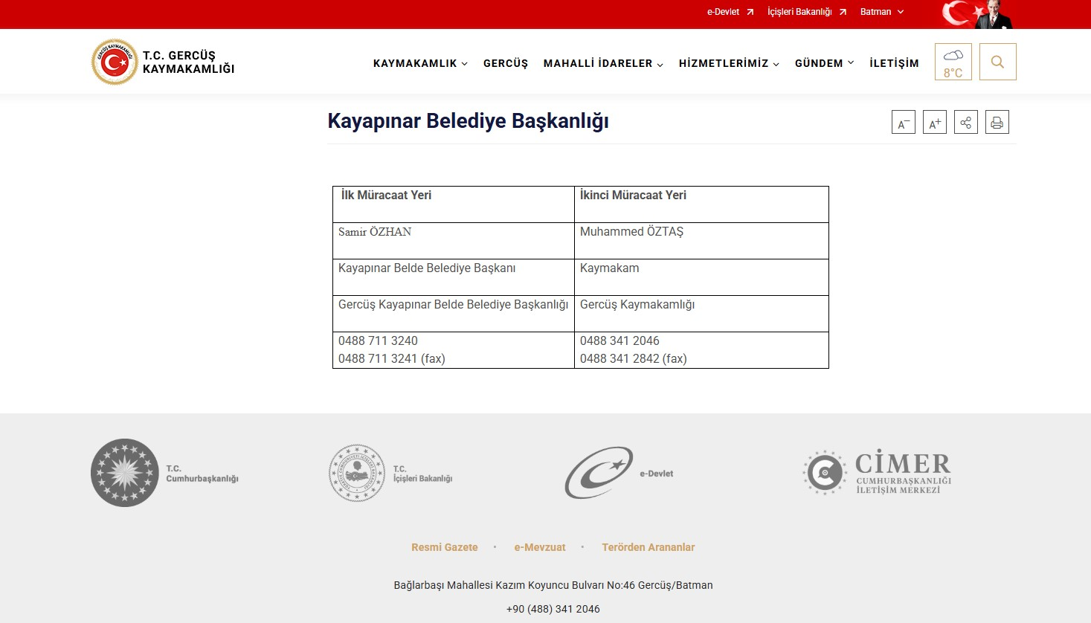
Figure 3. Gercüş District Governorship Website
The grievances, requests, suggestions and opinions of the public will be recorded through the GM contact person (GMCP) to be assigned by Kayapınar Municipality. All grievances are examined to be classified according to whether they are real or not and whether they are related to sub-project activities. If a grievance is deemed unsuitable for investigation because it is not genuine or not related to sub-project activities, the complainant will be provided with an explanation as to why the grievance could not be followed up. Grievances received within Kayapınar Municipality are evaluated and forwarded to the relevant units. Appropriate grievances are responded to according to the sub-projects social and environmental requirements defined in the ESMP and SEP.
All grievances received through direct phone calls, e-mails, face-to-face meetings/communications and the Website are recorded and after the recording process, will contact the complainant to explain the sub-project response process and the resolution of the grievance within ten (10) business days. The development of the solution may require consultation with the relevant person(s). The requester will be informed about the methodology followed. Each request must be evaluated with the utmost care, diligence, fairness and impartiality. The proposed solutions are communicated to the complainant with a second notification. If the proposed solution is accepted by the complainant, Kayapınar Municipality PIU will handle the grievance within 15 business days and take corrective measures to resolve the grievance. Grievance registration forms will be sent to the relevant GM Team member (Social Expert of the PMU Team or E&S Expert of the Contractor) on the same day (if possible, as soon as the grievance is received). A notification should be sent to the complainant by GMCP within two (2) business days of the receipt of the grievance, indicating that the grievance has been received and evaluated. The PIU Team will also have access to the grievance record to be created within the scope of the sub-project and will be continuously updated by GMCP or PIMU Social Expert. The Grievance Tracking Table will include the complainant/suggestor information, the date of receipt of the grievance/suggestion, the date and method of feedback to the complainant, the current status of the grievance (open, under review, closed, rejected) and the explanation of this current status (e.g. why it was rejected). It will include the closing/rejection and feedback dates. Grievances from contractors and subcontractors will be forwarded to GMCP by the Contractors’ E&S Specialist and will be recorded by GMCP using the grievance registration forms. On the same day, the data will be entered into the Grievance Registry and Grievance Database and made accessible to the PMU Team. During this period, the relevant parties responsible for managing the grievance will be in constant communication with the complainant and all communication will be recorded in the GM system through the Consultation Forms (see Annex-D). The grievance will be closed after the implementation of the decision is completed. After the grievance is closed or resolved, the complainant will be informed with the third notification and the relevant records (Grievance Closure Form, Grievance Record, etc.) will be kept. Unless an alternative agreement is made with the complainant, grievances will be closed within thirty (30) business days from the date of application. If the grievances are not resolved within thirty (30) business days, the extenuating circumstances will be documented and reported. After the grievance is resolved and the result is communicated to the complainant, the appointed GMCP will obtain the necessary signatures and close the grievance by filling out the Grievance Close Out Form (see Annex-B). If the decision is not accepted, it will be reconsidered and a revised decision may be proposed. Ultimately, the PIUs will be responsible for consolidating, monitoring and reporting the requests received, resolved and pending regarding the project. All this data will be compiled by the PIU to be reported at the end of each month.
Kayapınar Municipality/PIU Team will also implement additional measures to manage sensitive and confidential complaints, including those related to Sexual Exploitation and Abuse/Harassment (SEA/SH), in accordance with the World Bank ESF Good Practice Note on SEA/SH.

Grievance Mechanism for Workers
The GM for employees (applicable to both Kayapınar Municipality personnel and contractor and subcontractor employees) has been established in accordance with WB ESS2. The implementation of the GM for employees will be ensured throughout the financing life cycle of the sub-project. PIU requests contractors to develop and implement a grievance mechanism for the workforce, including sub-contractors, before starting work. Sub-contractors will prepare labor management procedures that will include a detailed description of the grievance mechanism for employees.
Employees are informed about employee rights, basic occupational health and safety, the grievance mechanism and its operation at the time they start work. An up-to-date list of contact points is available in employee handbooks and/or bulletin boards. All processes related to the grievance mechanism are conveyed in a language that employees can understand.
When employees detect a hazard or risk for which no precautions have been taken regarding occupational health and safety, they inform the employee representative, occupational safety specialist and/or occupational physician selected by the employees about this hazard or risk. The employee representative shall forward the details of the hazard and risk to the occupational health and safety board, if any, or to the employer/employer's representative, and request an evaluation. If the problem is not resolved, all legal rights are reserved by applying to the contractor/subcontractor level GM contact persons through the grievance boxes located at the workplaces. Requests regarding employee rights and occupational health and safety are collected in grievance boxes placed in areas that employees can easily access.
The collected grievances and suggestions are carried out in accordance with the periods determined in the process of the grievance mechanism.
After the applications are evaluated, if there is an imminent, urgent and vital danger, a notification can be made directly to the Labor Life Communication Center, ALO 170 line or the Provincial Labor and Employment Institutions Directorates operating in the province. Upon receipt of the requests, the workflow grievance mechanism is carried out in accordance with the workflow chart.
The Kayapınar Municipality/PIU Team will be ready to handle grievances regarding working conditions. The Kayapınar Municipality/PIU Team will evaluate grievances and suggest solutions for direct and contracted employees using this internal GM, which all sub-project employees can easily access.

Sensitive and Confidential Grievances
Specific procedures will be implemented by the subproject in order to address sensitive and confidential grievances, particularly those that are related to Sexual Exploitation and Abuse/Harassment (SEA/SH). These measures will be implemented in accordance with the World Bank ESF Good Practice Note on SEA/SH.
First of all, the complaining party has the right to remain confidential under the Turkish Constitution and the right to apply to the court at any time (in accordance with the Turkish Labor Law No. 4857 and the Turkish Civil Code No. 4721). In addition, Sub-Borrower personnel and sub-project employees will be able to directly communicate (via e-mail) with the Ethics Committee based at İLBANK Head Office in case of sensitive grievances. This issue will be clarified in the consultations carried out and in the introduction of the grievance mechanism. For cases related to gender-based violence, SEA/SH in the workplace or any potential child abuse in sub-project implementation/sub-project sites, the grievance will be directed to the relevant legal authorities or service providers by the Social Focal Point (based at ILBANK Head Office).

Grievance Mechanism Flow Chart
Grievance mechanism operation diagram details are given in Table 6.
Table 6. Grievance Mechanism Flow Chart
Grievance Process | Requirement / Action
Submission of a grievance | Receiving the grievance by any communication channel explained above. (At this point, if the grievance is a sensitive grievance involving child abuse, sexual harassment abuse or Gender Based Violence (GBV) immediate action will be taken within 2 days after receiving of the grievance. For the cases relevant to sexual exploitation and abuse/sexual harassment at workplace or any potential child abuse in the project sites, the grievance will be directed by the GM focal point (based in ILBANK headquarter) to relevant legal authorities/service providers such as Ministry of Family and Social Services and Prosecutors Office.”)
Registration of grievance | Registering/recording through making an entry in the sample grievance register table. All the grievances will be registered within two working days and feedback will be given to the complainant. If the complainant requests that this grievance be treated anonymously, this grievance will be recorded anonymously and the request will be met.
Forwarding of grievance | The grievance is forwarded to relevant persons (site manager on construction sites and experts of the PIU) responsible for handling the grievance in not later than three working days upon receiving the grievance (except for any emergent grievance, which would be handled as appropriate).
Evaluation of a grievance | Evaluating the grievances within 10 working days and determining whether the grievance meets the admissibility criteria. If the grievance is not valid, providing relevant explanation to the complainant.
Response for a grievance | If the grievance is valid, identifying and taking corrective measures for resolving the grievance in not later than 15 working days upon receiving.  All comments and grievances will be responded to either verbally or in writing, in accordance with the preferred method of communication specified by the complainant, if contact details of the complainant are provided.  At this point, it should be noted that the action taken and the result of this anonymously recorded grievance should be shared on the Kayapınar Municipality website, so that anonymous complainants is informed about their grievance and the results.
Recording the result of a grievance | Recording the result of the grievance in register table.
Right to Appeal | If the grievance cannot be resolved with the existing process, applicants can always apply to relevant legal institutions. Such institutions can be summarized as follow:  - Civil Courts of First Instance  - Administrative Courts  - Commercial Courts of First Instance  - Labor Courts, and  - Ombudsman (https://ebasvuru.ombudsman.gov.tr/)

MONITORING AND REPORTING

Summary of how SEP implementation will be monitored and reported
It is the responsibility of Kayapınar Municipality to ensure that the SEP is fully integrated and implemented in all sub-project activities. All stakeholders will be consulted and will be able to use the GM throughout the sub-project lifecycle. On the other hand, the SEP will form part of all tender documents related to the physical works within the scope of the sub-project.
As part of the World Bank ESF requirements, the draft ESMP and draft SEP will be made public when approved for public disclosure and approved by İLBANK, and the disclosure will be the responsibility of the sub-project Implementers and the consultant firm Kayapınar Municipality. Kayapınar Municipality will ensure that the SEP is published in hard copy and on its website. Similarly, several copies of all prepared environmental and social documents will be available locally in Kayapınar Municipality, where affected groups such as the Mukhtar offices operating in the Gercüş District of Batman Province and local NGOs can easily access. The SEP is a dynamic document and will be reviewed, updated and approved by ILBANK when necessary (e.g. changes in the design of sub-project components according to Environmental and Social Monitoring Reports (ESMRs), stakeholders' requests/grievances regarding the sub-project. Implementation of the SEP throughout the implementation of the sub-project, elimination of non-conformities, etc.). Kayapınar Municipality will be responsible for making a statement through communication channels for each updated version of the SEP.
Kayapınar Municipality will monitor the sub-project throughout its lifetime considering the stakeholder engagement process. The approved SEP will be reviewed biannually and updated if required according to the project improvements and the unexpected public reactions. The GM established by the Kayapınar Municipality will be used effectively and the statistical summary of the outputs of GM will be reported to ILBANK together with all the requests received, resolved and unresolved, Grievance Register, Grievance Monitoring Table and Environmental and Social Monitoring Reports (ESMRs) on a monthly basis. With monthly reporting, total number of grievances, monthly number of grievances, distribution of grievances by subject, gender, grievances answered within 1 days, grievances resolved within 30 days, list etc. is necessary.
7.2. Reporting back to stakeholder groups
During the preparation and construction phases of the Subproject, the construction contractor will prepare monthly reports on environmental and social performance for submission to Kayapınar Municipality, which will include updates and indicators on the implementation of the stakeholder engagement plan. The monthly reports will be shared with ILBANK and ILBANK will provide quarterly reports to the World Bank.
The person/unit to be assigned by Kaayapınar Municipality will provide feedback to stakeholder groups through public meetings, primarily in the subproject impact area. The summary of the public meetings will be published after the removal of identifying information in accordance with the Law on the Protection of Personal Data. Feedback received through the Grievance Mechanism (GM) will be responded to in writing and verbally. Important updates on the sub-project will be published on the website of Kayapınar Municipality.

ANNEXES

Annex-A
Sample Grievance Submission Form
KAYAPINAR MUNICIPALITY

SOLAR POWER PLANT PROJECT
 |  | GRIEVANCE FORM
Person Filling Out the Form: |  |  |  | Date and time:
Inteviev Agenda: |  |  |  | Reference No: Kayapınar Municipality-Project Code-0001-2..
- INFORMATION ABOUT THE COMPLAINANT
Name surname:  If the complainant requests that this grievance be treated anonymously, this grievance will be recorded anonymously and the request will be met. |  |  |  | How received the Grievance:
TC Identification number: |  |  |  | Telephone / Toll Free Line
Telephone: |  |  |  | Face to Face Meeting
Address: |  |  |  | Website / Email
Email: |  |  |  | Other (Explain)
Stakeholder Type
Public | PAP | Private Enterprise | Trade Association |  | NGO
Interest Groups | Industrial Assosiaction | Labor Union | Media |  | University
- DETAILED INFORMATION ABOUT THE GRIEVANCE
Description of the grievance:
Solution method requested by the complainant
Registrant Name Surname/Signature |  | Complainant Name Surname/Signature

Annex-B
Sample Grievance Close Out Form

KAYAPINAR MUNICIPALITY

SOLAR POWER PLANT PROJECT
 | GRIEVANCE CLOSE OUT FORM
Reference form:
- DETERMİNATİON OF CORRECTIVE ACTION
1
2
3
4
5
- CLOSE OUT THE GRIEVANCE
This section will be filled and signed by the Complainant in case the grievance stated in the “Grievance Registration Form” is resolved
Name Surname /  Signature of the Person  Closing the Grievance/Date | Name Surname /  Signature of Complainant/Date

Annex- C
Grievance Database Form
No | Complaint Register  Number | How Complaint is Received (Grievance Form, Community Meeting, Telephone) | Level of Grievance (Municipality/Utility Level, Regional) | Date of Complaint  Received | Location of Complaint  Received | Name of Person Receiving Grievance | Land Parcel #  (If complaint is related to land) | Complainant Information |  |  |  |  | Project Component Related to Complaint | Grievance Category (expropriation/land acquisition related, environmental issues, damages to structures etc.) | Complaint Summary | Grievance Status (open, closed or pending) | Action Taken |  |  |  | Supporting Documents for Grievance Closeout (bank receipt for compensation, grievance closure protocol)
 |  |  |  |  |  |  |  | Name/Surname | ID Number | Telephone/  email | Village-District | Gender |  |  |  |  | Responsible Person/Department | Action Planned | Due Date of the Addressing the Grievance | Date of Action Taken
1

Annex-D
Sample Consultation Form (For Stakeholder Engagement Meeting(s))
KAYAPINAR MUNICIPALITY

SOLAR POWER PLANT PROJECT
 |  | CONSULTATION FORM
Person Filling Out the Form: |  |  |  | Date time and place:
Meeting Agenda: |  |  |  | Interview Registration Number:
- INTERVIEW INFORMATION
Interviewed Institution: |  |  |  | Form of Communication
Name and Surname of the Interviewee: |  |  |  | Telephone / Toll Free Line
Telephone: |  |  |  | Face to Face Meeting
Address: |  |  |  | Website / Email
Email: |  |  |  | Other (Explain)
Stakeholder Type
State agency | PAP | Private Enterprise | Job Room |  | NGO
Interest Groups | Industrial Unions | Labor Union | Media |  | University
- INTERVIEW DETAILS (List of Invitees and actual participants, Summary of presentations made by whom, minutes of meeting will be annexes of this form.)
Questions about the project:
Concerns/feedback regarding the project:
Responses to the views expressed above:

Annex-E
Minutes of Public Consultation Meeting
Türkiye Public and Municipal Renewable Energy Project (PUMREP)

KAYAPINAR MUNICIPALITY
SOLAR POWER PLANT PROJECT

Minutes of Public Consultation Meeting

Meeting Date: 27.10.2025
Meeting Time: 14:00
Meeting Venue: Kayapınar Municipality Meeting Hall
PUBLIC CONSULTATION
Within the scope of the sub-project, the Environmental and Social Management Plan Checklist (ESMP-Checklist) and the Stakeholder Engagement Plan (SEP) have been prepared in accordance with Turkish environmental and social legislation, as well as the World Bank Environmental and Social Standards, Safeguard Policies, World Bank General EHS Guidelines, Industry Sector Guidelines, and İLBANK’s PUMREP Environmental and Social Management System (ESMS) and Stakeholder Engagement Plan (SEP).
As part of the stakeholder engagement process, a Public Consultation Meeting was held on 27 October 2025 at 14:00 in Kayapınar Municipality Meeting Hall. To inform the local community about the meeting, printed materials such as brochures and posters were prepared and displayed, and announcements were published on the Kayapınar Municipality website as well as in local and national newspapers.

Meeting Summary
At the Kayapınar Municipality Public Consultation Meeting, a representative from the consulting firm provided detailed information about the process and content of the reports prepared for the implementation of the subproject. A presentation was made outlining the benefits the subproject will provide to the municipality and the local community. The presentation is included in Annex-6.
The meeting was attended by 1 municipal staff members, 17 local residents, making a total of 18 participants.
The area where the sub-project will be established (as a neighborhood, block and parcel), project power, equipment and technical specifications to be used, annual production of the project were specified and information was given that the legislative obligations were fulfilled.
Within the scope of the Public Consultation Meeting; the consultant company environmental expert conveyed the environmental and social risks of the sub-project from the content of the ESMP Report, the works planned to prevent the said risks, the effects of the geographical location of the region where the project will be located and the climate conditions on the project and the analyses made on possible natural disasters. In addition, during the Public Consultation Meeting, information was provided to the participants regarding the grievance channels that can be used to submit any complaints, concerns, suggestions, or opinions during the pre-construction, construction, and operation phases of the project. In line with the information provided, the meeting was concluded with questions and answers and lasted approximately 45 minutes.

Question and Answer Section
Question 1.
Name / Occupation | Yenice Neighborhood Resident
Will we be able to sell the electricity we produce?
Answer 1.
Name / Occupation | CA Engineering
The energy generated by the project will first be utilized to meet the water demand. Once the water needs have been fully satisfied, the process of selling the surplus energy can begin.

Meeting Conclusion
The Public Consultation Meeting, which lasted approximately 45 minutes, included a presentation by representatives of the consulting firm providing information about the project. Following the presentation, a question-and-answer session was conducted to gather participants’ views and inquiries. During the meeting, information was shared regarding the environmental, social, and economic aspects of the Kayapınar Municipality PV Project, as well as the next phase of the sub-project. In addition, participants were informed about the grievance mechanism available for submitting complaints, requests, or suggestions throughout the project duration. The meeting concluded after collecting participants’ feedback and recommendations.

Participant List
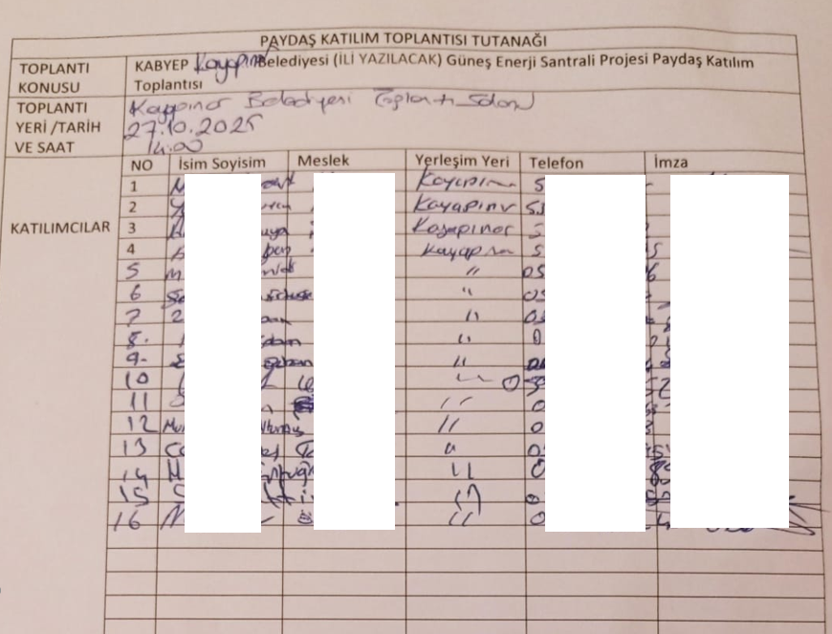

ATTACHMENTS

Annex-1: Photo of the Public Consultation Meeting (27.10.2025)
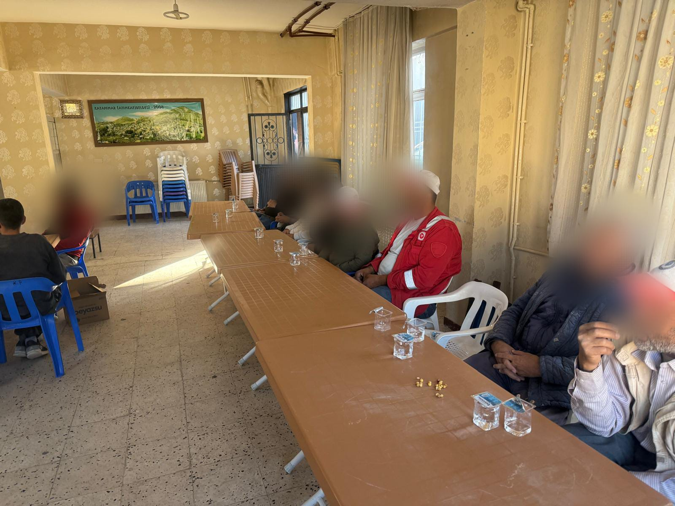
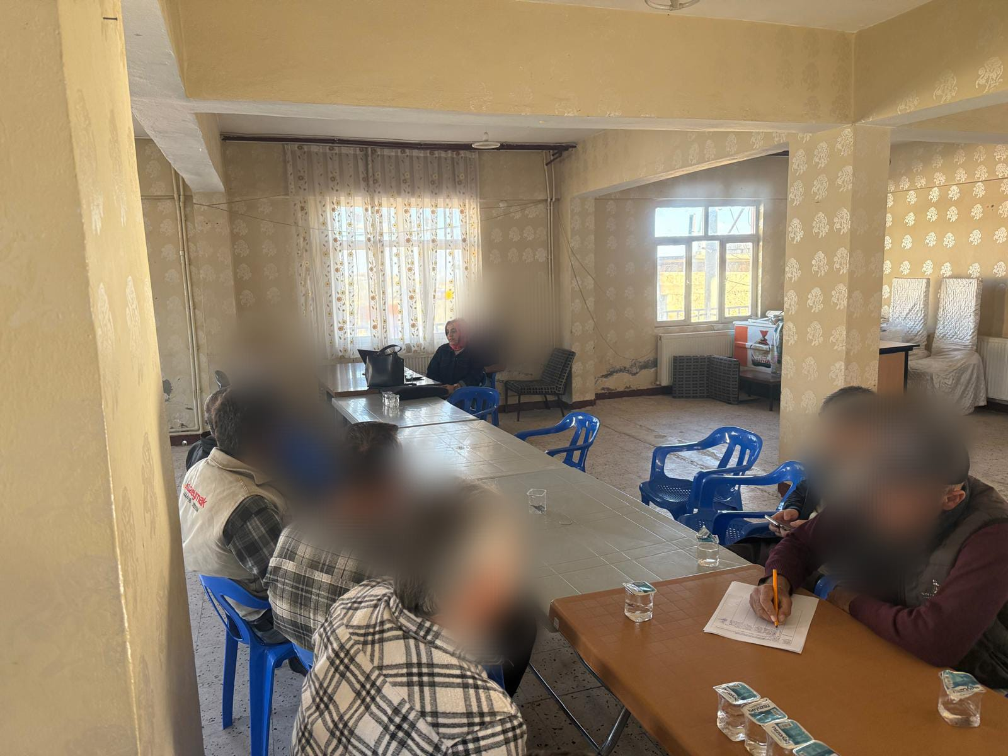
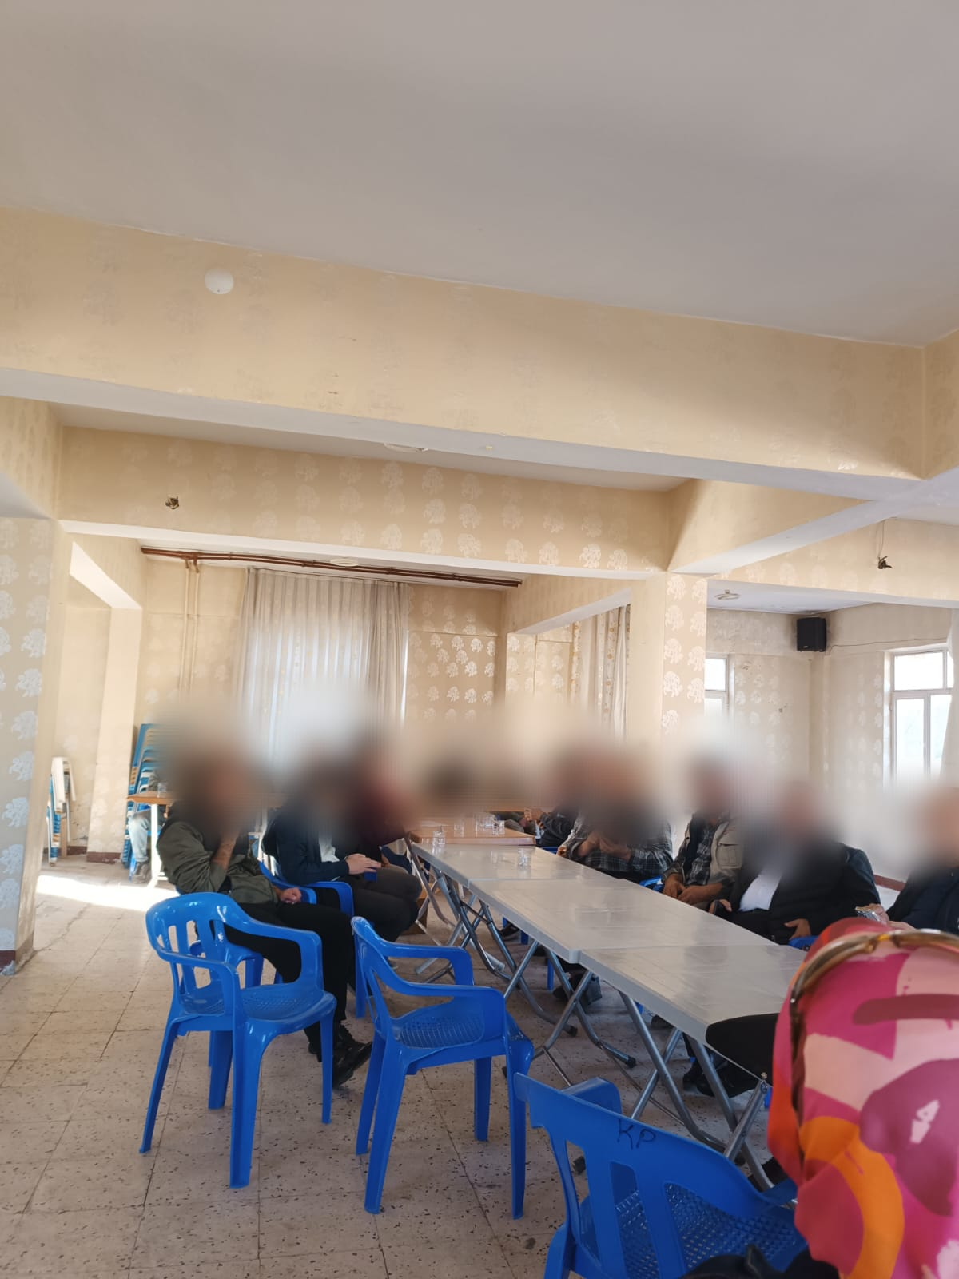

Annex-2: National Newspaper Advertisement (Newspaper Announcement Date –Takvim 16.10.2025)
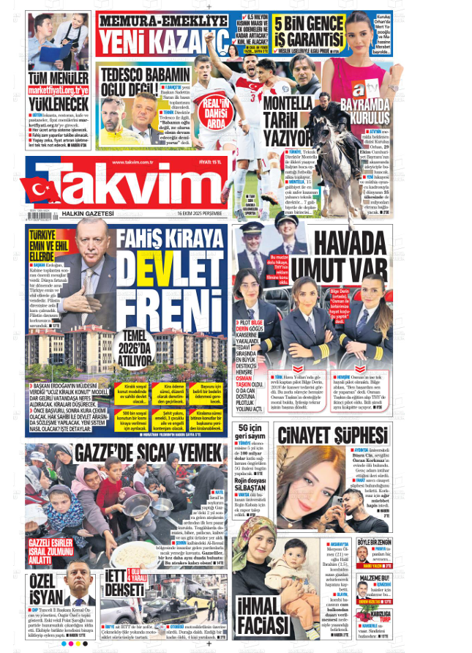
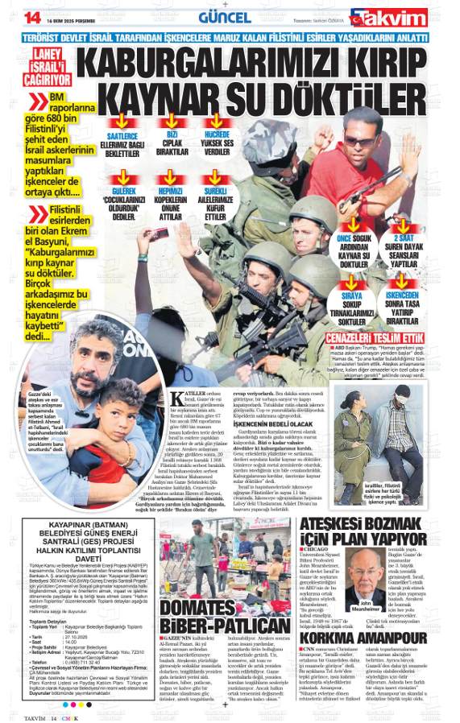

Annex-3: Local Newspaper Advertisement (Newspaper Advertisement Date – GercüşHaber Newspaper -16.10.2025)
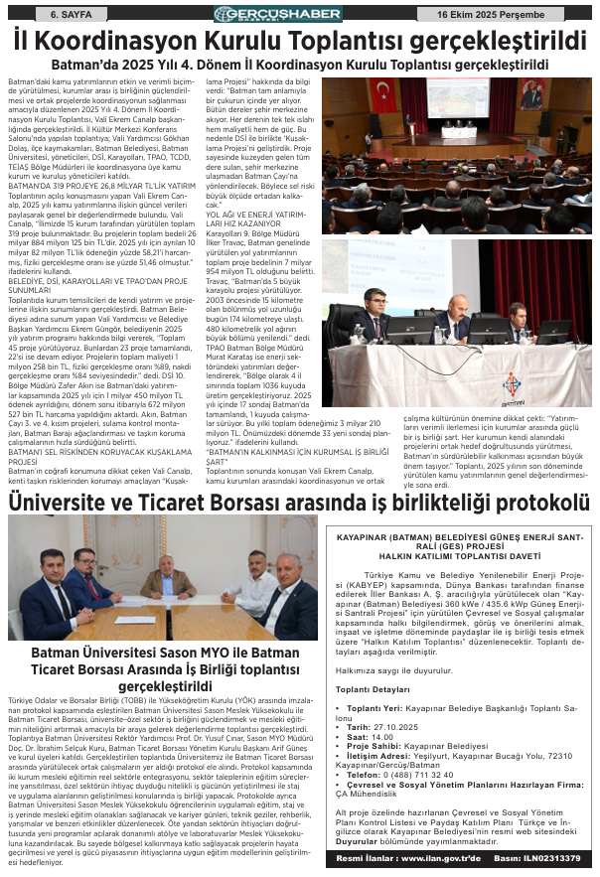

Annex-4: Kayapınar Municipality Announcements (16.10.2025)
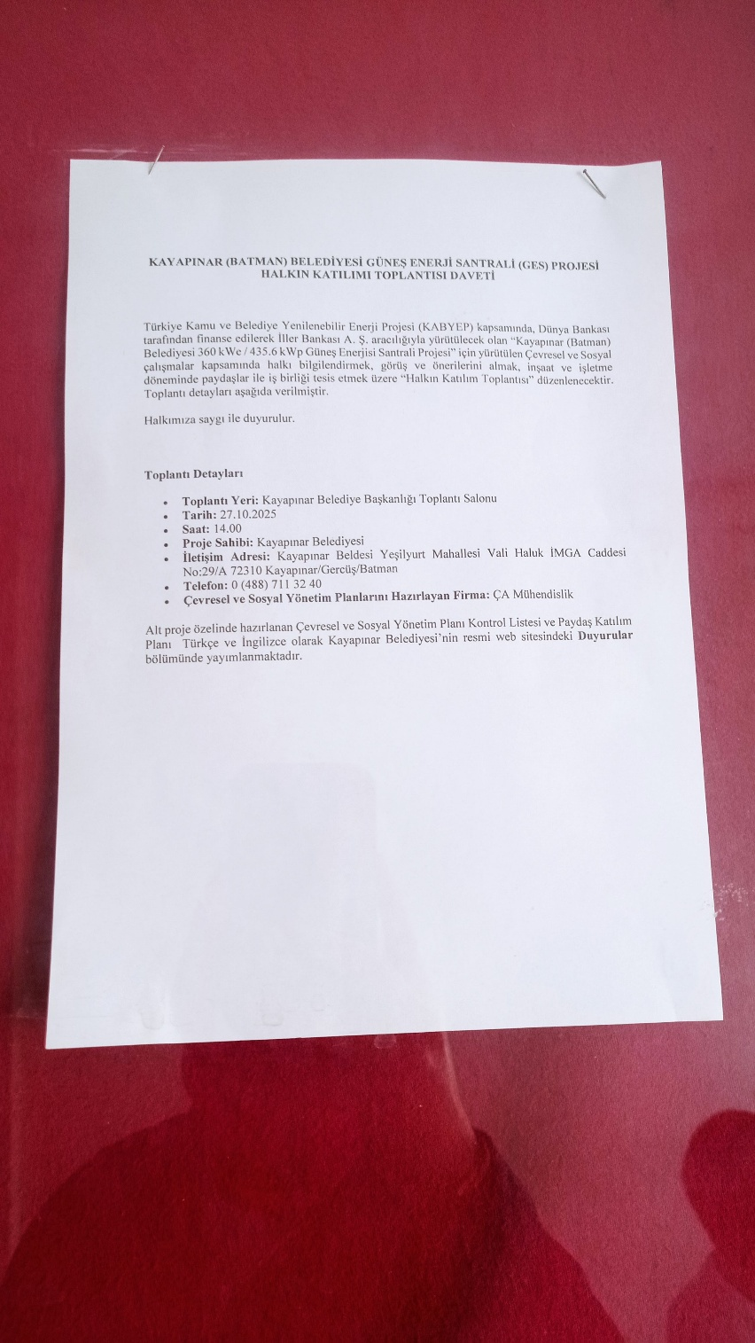
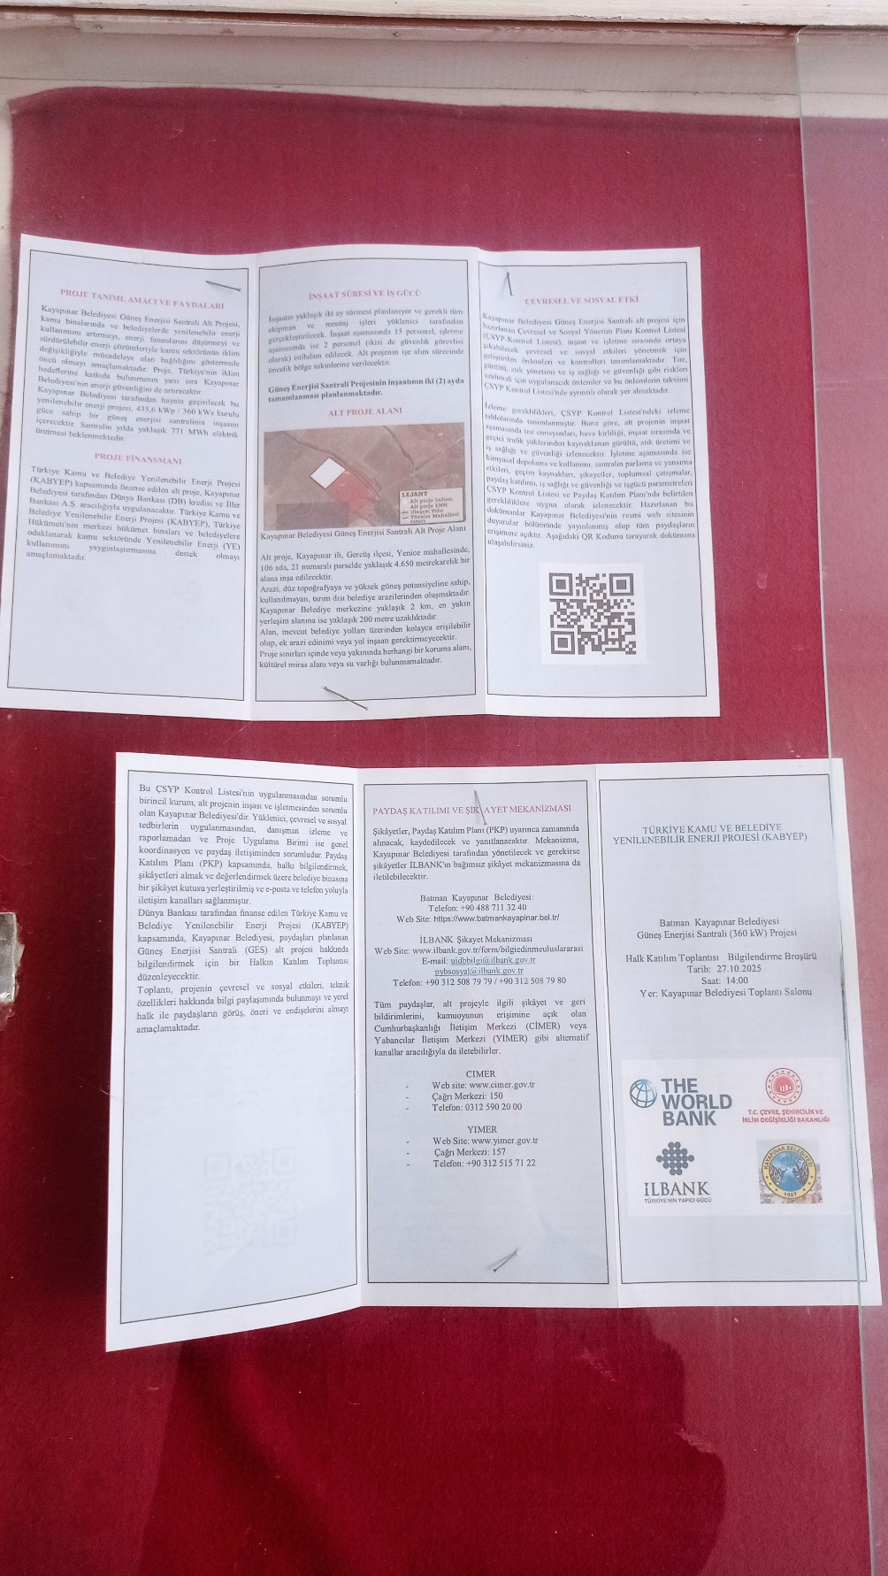
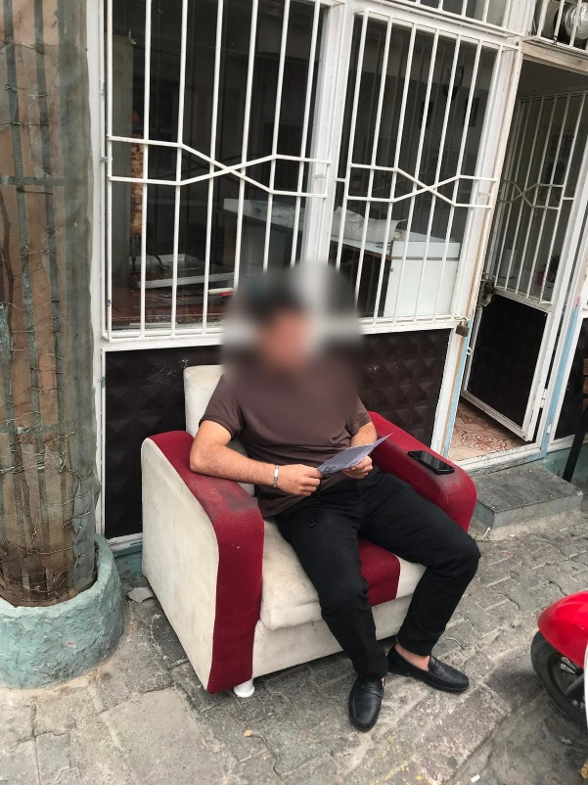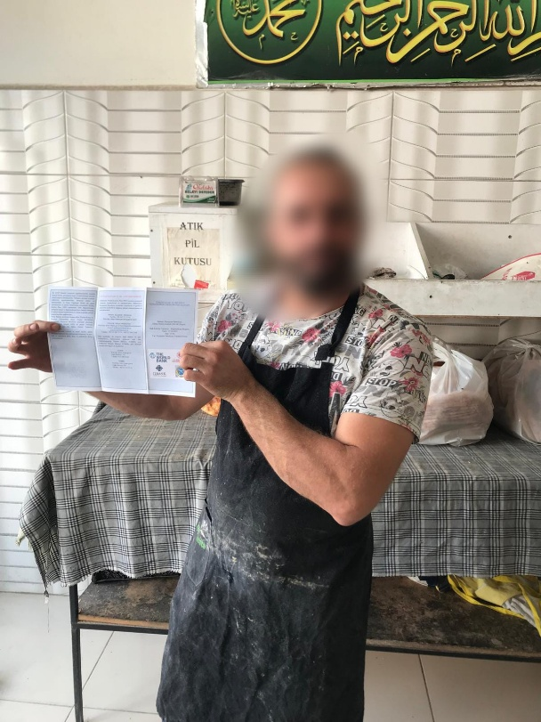
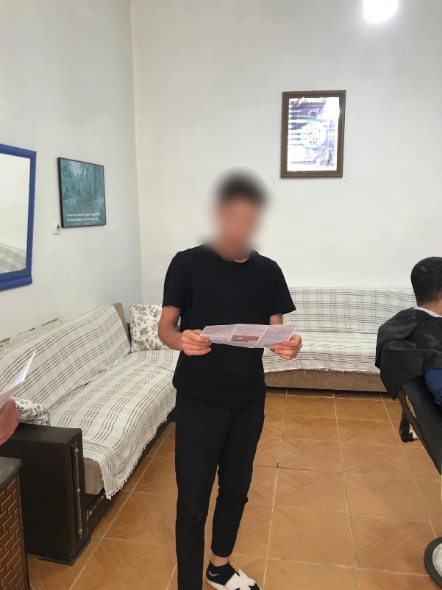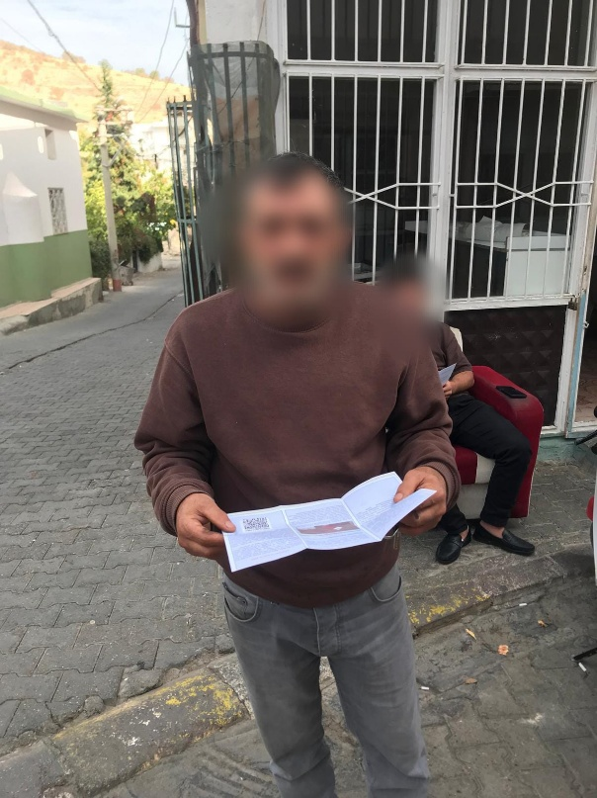

Annex-5: Kayapınar Municipality Public Consultation Meeting Brochure
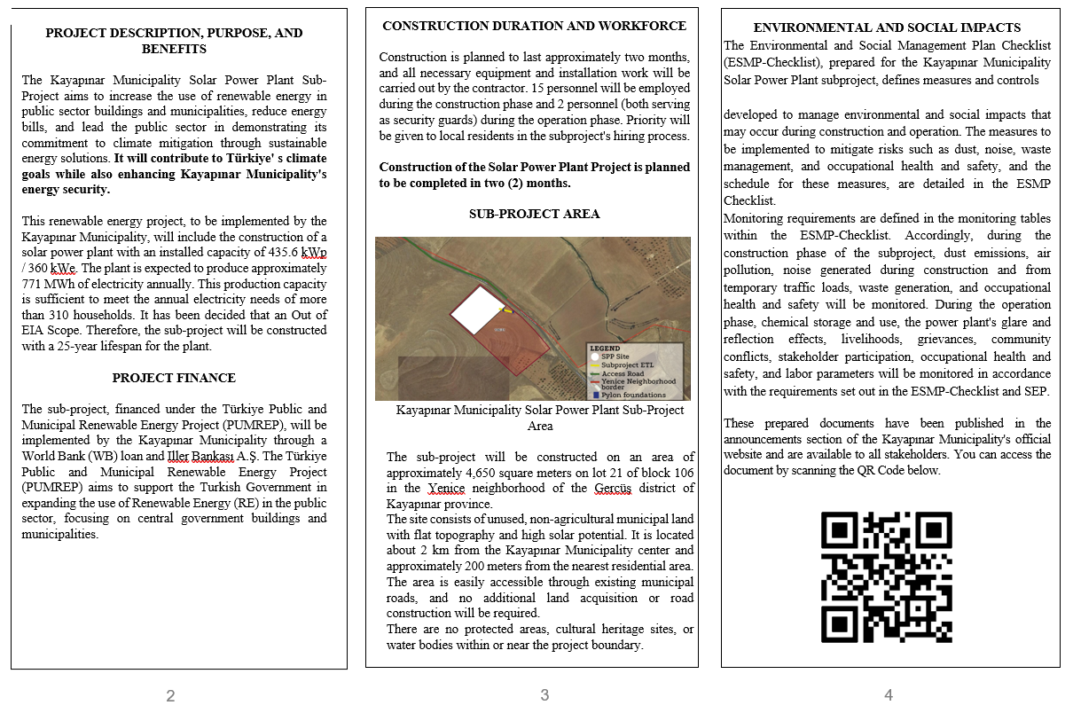
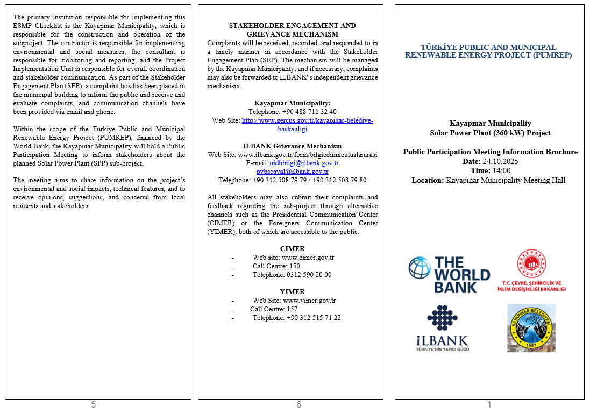

Annex-6: Public Consultation Meeting Presentation
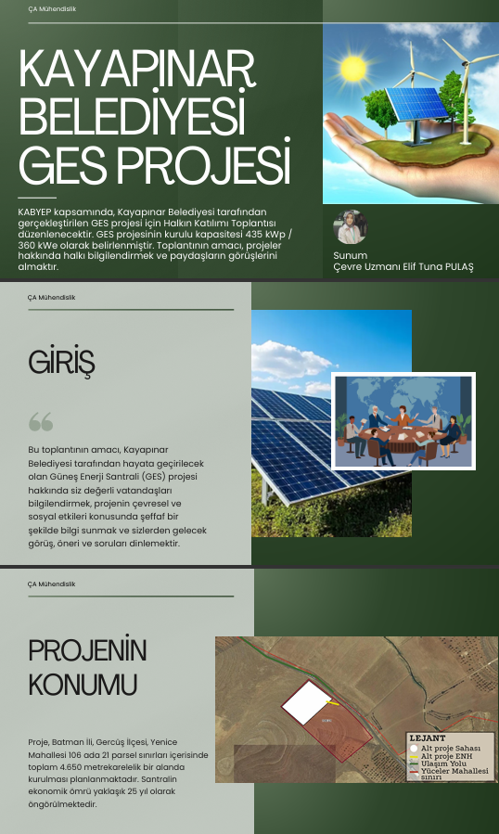
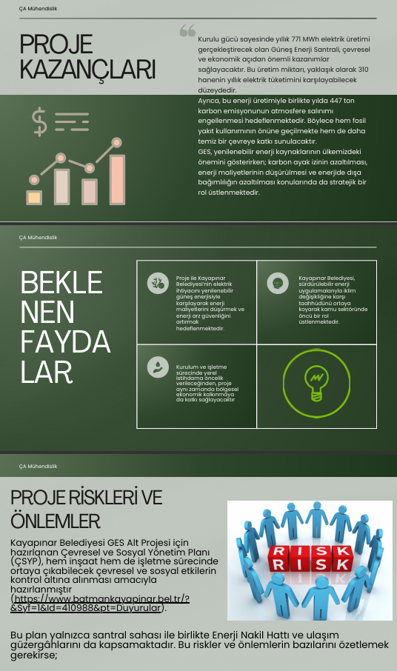
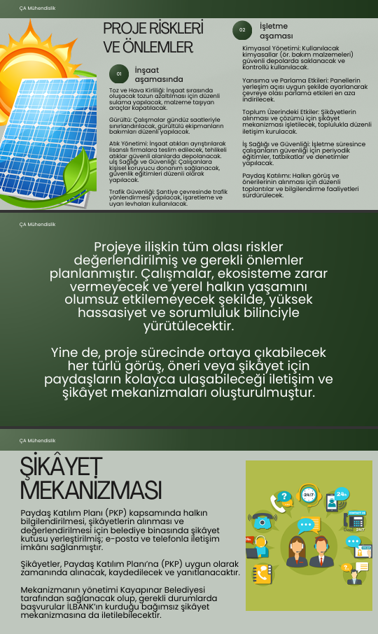
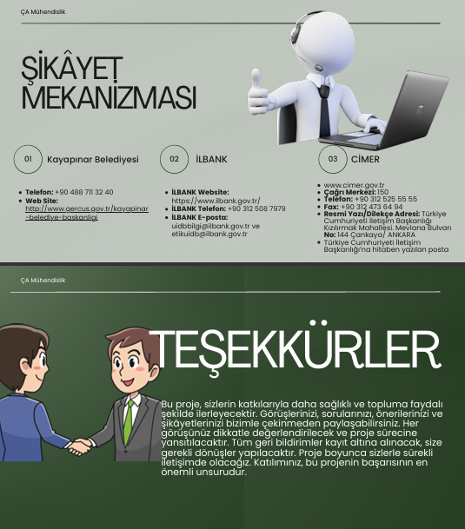

https://www.ilbank.gov.tr/sayfa/ilbank-environmental-and-social-policy
http://www.gercus.gov.tr/kayapinar-belediye-baskanligi
http://www.gercus.gov.tr/kayapinar-belediye-baskanligi

